



**FACULTY OF ENGINEERING AND TECHNOLOGY BACHELOR OF TECHNOLOGY**

**SOFTWARE TESTING AND QUALITY ASSURANCE (3033105377)**

**NAME: - PANDEY SANJIT VINOD**   
**ENROLLMENT NO: - 2203051050314**   
**DIVISION: - 7A13**   
**ROLL NO : 25**

**SEMESTER VII**   
**Computer Science and Engineering Department**

|  |
| --- |
| Laboratory Manual |

|  |
| --- |
| Session:2025-26 |



**Faculty of Engineering & Technology Subject Name: STQA**   
**Subject Code: 303105377**   
**B.Tech. CSE Year: 4rd / Semester: 7th**

**CERTIFICATE**

*Ms.* ***KRITIKA JAIN*** *with Enrollment No.* ***2203051050314*** *has successfully completed his/her laboratory experiments* ***Software Testing and Quality Assurance (303105377)*** *from the department of* ***Computer Science and Engineering*** *during the academic year* ***2025-2026.***



**Date of Submission ….…………… Staff In charge …..……………**

**Head of Department………….……**

**Enrollment No: 2203051050314 Student Name: KRITIKA JAIN Page |**



**Faculty of Engineering & Technology Subject Name: STQA**   
**Subject Code: 303105377**   
**B.Tech. CSE Year: 4rd / Semester: 7th**

**INDEX**

|  |  |  |  |  |  |  |  |
| --- | --- | --- | --- | --- | --- | --- | --- |
| **Sr.**  **No** | **Experiment Title** | **Page No** | | **Start Date** | **Completion Date** | **Sign** | **Marks/ 10** |
| **From** | **To** |
| **1** |  |  |  |  |  |  |  |
| **2** |  |  |  |  |  |  |  |
| **3** |  |  |  |  |  |  |  |
| **4** |  |  |  |  |  |  |  |
| **5** |  |  |  |  |  |  |  |
| **6** |  |  |  |  |  |  |  |
| **7** |  |  |  |  |  |  |  |
| **8** |  |  |  |  |  |  |  |
| **9** |  |  |  |  |  |  |  |
| **10** |  |  |  |  |  |  |  |

**Enrollment No: 2203051050314 Student Name: KRITIKA JAIN Page |**



**Faculty of Engineering & Technology Subject Name: STQA**   
**Subject Code: 303105377**   
**B.Tech. CSE Year: 4rd / Semester: 7th**

**Experiment No: 1**

**Aim: - Design test cases using Boundary Value Analysis (BVA).**

**Solution:-**

**Theory:**

Boundary Value Analysis (BVA) is a black-box test design technique that focuses on the

**boundaries of input values**. The core idea is simple: errors often occur at the **edges** of input

domains rather than in the middle. So instead of testing all possible inputs, BVA tests the

values at the edge—where things tend to go wrong.

**Boundary Value Analysis** focuses on values at the edge of valid ranges where bugs

frequently occur.

The technique assumes that if a system works correctly at its boundaries, it likely works

throughout the input range.

For a valid age range of 18–60, BVA would include:

• Just below the lower boundary: 17

• At the lower boundary: 18

• Just above the lower boundary: 19

• Just below the upper boundary: 59

• At the upper boundary: 60

• Just above the upper boundary: 61

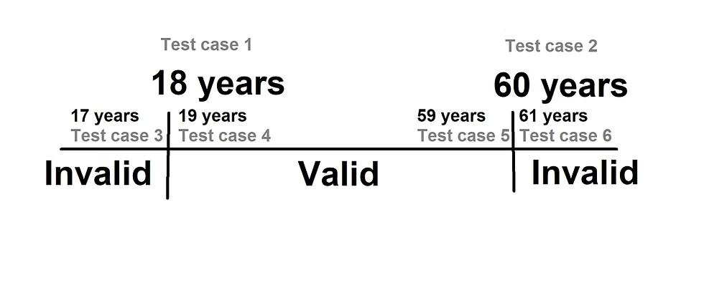

**ProblemStatement**

Create a program to check if a given integer input x is within the **valid range of 18 to 60**

(inclusive). Use **BVA** to design your test cases.

**Formula :**

- **min - 1, min, min + 1, max - 1, max, max + 1**

**Enrollment No: 2203051050314 Student Name: KRITIKA JAIN Page |**



**Faculty of Engineering & Technology Subject Name: STQA**   
**Subject Code: 303105377**   
**B.Tech. CSE Year: 4rd / Semester: 7th**

**Test Case Design (Using BVA)**

|  |  |  |  |
| --- | --- | --- | --- |
| **TestCase ID** | **Input** | **Expected Output** | **Type** |
| TC01 | 9 | Invalid Input | Just below LB |
| TC02 | 10 | Valid Input | At LB |
| TC03 | 11 | Valid Input | Just above LB |
| TC04 | 99 | Valid Input | Just below UB |
| TC05 | 100 | Valid Input | At UB |
| TC06 | 101 | Invalid Input | Just above UB |

**Code:**

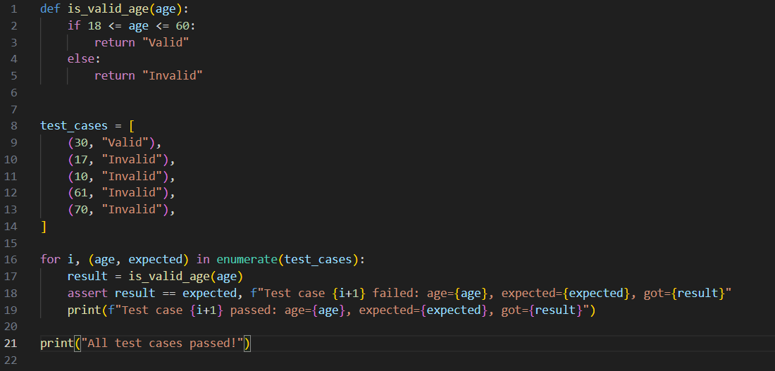

**Output:**

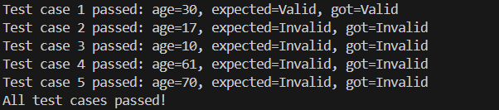

**Analysis**   
 • All test cases passed successfully.

• The function correctly handles:   
• A **mid-range valid input** (30)   
 Values **below** the valid lower bound (10, 17) •  
• Values **above** the valid upper bound (61, 70)   
• However, **no test cases** exist for **boundary edges**: 18 (lower bound) and 60 (upper bound).

**Enrollment No: 2203051050314 Student Name: KRITIKA JAIN Page |**



**Faculty of Engineering & Technology Subject Name: STQA**   
**Subject Code: 303105377**   
**B.Tech. CSE Year: 4rd / Semester: 7th**

• These are **critical for Boundary Value Analysis (BVA)**.

• Without testing 18 and 60, it’s unclear if the function handles **inclusive edges**  properly (even though logically it should).

**Conclusion:**

The given code defines a function `is_valid_age(age)` that checks if an age is between 18 and 60 (inclusive). If so, it returns "Valid"; otherwise, it returns "Invalid". The script then tests this function with several cases, confirming correct behavior for ages both inside and outside the valid range. If all test cases pass, it prints "All test cases passed!" This confirms that the function correctly validates ages as intended..

**Enrollment No: 2203051050314 Student Name: KRITIKA JAIN Page |**



**Faculty of Engineering & Technology Subject Name: STQA**   
**Subject Code: 303105377**   
**B.Tech. CSE Year: 4rd / Semester: 7th**

**Experiment No: 2**

**Aim: - Design test cases using Equivalence class partitioning.**

**Solution:-**

Equivalence Class Equivalence Class Partitioning is a **black-box testing technique** that organizes test inputs into groups where the system is expected to behave the same. It assumes that testing **one representative** value from each group is enough to verify correct system behavior for that entire group—making your testing **efficient and focused**.

**Partitioning Input Domain**: Divide all possible inputs into **equivalence classes**—sets of values that are logically treated the same by the software.

**Valid Classes**: Contain values the system should accept.

**Invalid Classes**: Contain values the system should reject or handle as errors.

**Test Reduction**: Instead of testing every single input, you choose **one representative value** from each class, drastically reducing the number of test cases.

Equivalence Class Partitioning, we group input values into **classes** based on expected behavior. Each class will have one **representative value**, unlike BVA which tests multiple points at each boundary.

|  |  |  |  |
| --- | --- | --- | --- |
| **Class Type** | **Range of Inputs** | **Representative Value** | **Expected Result** |
| Valid Class | 18 to 60 | 30 (or any value in range) | Accepted |
| Invalid Class (low) | Less than 18 | 17 | Rejected |
| Invalid Class (high) | Greater than 60 | 61 | Rejected |

Equivalence Class Partitioning doesn't require testing *just below* and *just above* boundaries unless you combine it with BVA. You simply check:

• One value **within** the range (like 30)

• One value **below** the range (like 17)

• One value **above** the range (like 61)

**Formula :**

**Total Test Cases = (Number of valid equivalence classes) + (Number of invalid equivalence classes)**

This means:

• For each input condition, identify all valid ranges or types.

• Then identify invalid ranges or types that fall outside those bounds.

**Enrollment No: 2203051050314 Student Name: KRITIKA JAIN Page |**



**TestCase table :**

**Faculty of Engineering & Technology Subject Name: STQA**   
**Subject Code: 303105377**   
**B.Tech. CSE Year: 4rd / Semester: 7th**

|  |  |  |  |
| --- | --- | --- | --- |
| **Test Case ID** | **Input** | **Expected Output** | **Category** |
| TC01 | 18 | Valid | Lower Boundary |
| TC02 | 17 | Not Valid | Just Below LB |
| TC03 | 19 | Valid | Just Above LB |
| TC04 | 59 | Valid | Just Below UB |
| TC05 | 60 | Valid | Upper Boundary |
| TC06 | 61 | Not Valid | Just Above UB |
| TC07 | 200 | Not Valid | Far Above UB |
| TC08 | 87 | Not Valid | Above UB |
| TC09 | 1 | Not Valid | Far Below LB |
| TC10 | 9 | Not Valid | Below LB |
| TC11 | 0 | Not Valid | Zero Boundary |
| TC12 | -5 | Not Valid | Negative Input |

**Code:**

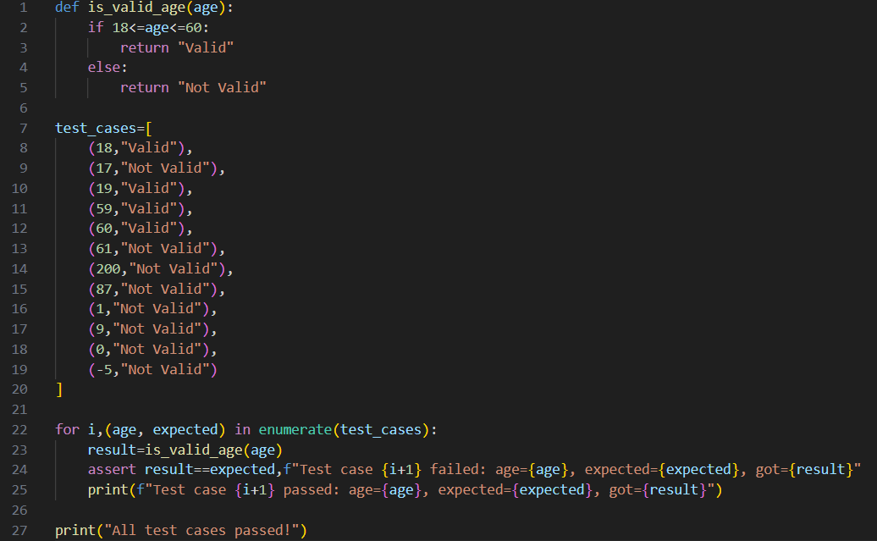

**Enrollment No: 2203051050314 Student Name: KRITIKA JAIN Page |**



**Output:-**

**Faculty of Engineering & Technology Subject Name: STQA**   
**Subject Code: 303105377**   
**B.Tech. CSE Year: 4rd / Semester: 7th**

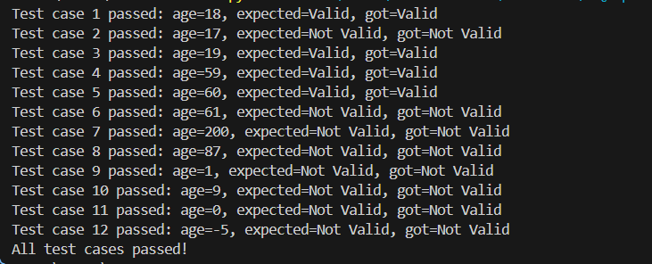

**Analysis:**   
Positives:   
 • Boundary Value Analysis (BVA) is fully covered.

• Robustness Testing is also well addressed:   
 oIncludes large upper values (200)   
 oNegative values (-5)   
 oZero (0)   
Areas for Minor Improvement:   
 • Could include a midpoint value, like (39, "Valid") or (30, "Valid"), just for completeness.

• Could add a non-integer input test (e.g., "25", 25.5) — if this is a real-world validation scenario.

**Conclusion:**

The code defines a function `is_valid_age(age)` that checks if an age falls within the inclusive range of 18 to 60. If the age is within this range, the function returns "Valid"; otherwise, it returns "Not Valid". The program thoroughly tests the function with various edge and typical cases, confirming that the function correctly   
distinguishes valid and invalid ages as required. All test cases pass, demonstrating that the function is robust and behaves as expected for both boundary and out-of-range values.

**Enrollment No: 2203051050314 Student Name: KRITIKA JAIN Page |**



**Faculty of Engineering & Technology Subject Name: STQA**   
**Subject Code: 303105377**   
**B.Tech. CSE Year: 4rd / Semester: 7th**

**Experiment No: 3**

**Aim: - Design independent paths by calculating cyclometric complexity using date problem in python.**

**Solution:-**   
**Theory**   
**Cyclomatic Complexity** is a software metric introduced by **Thomas McCabe** to measure the complexity of a program’s control flow.

**Purpose:**   
 Counts **linearly independent paths** in a program. •  
 • Helps determine the **minimum number of test cases** for **100% branch coverage**. • Assesses **maintainability** and **testability**.

**Formulas:**   
 1.**Graph-based:**   
M=E−N+2PM = E - N + 2P   
 • *E* = Edges, *N* = Nodes, *P* = Connected components   
 2.**Decision-based (simpler):**   
M=D+1M = D + 1   
 •  
 *D* = Number of decision points (e.g., if, while, for)  **Independent Path:**   
An **independent path** includes at least one **new edge** not covered by other paths.

✔ Ensures **complete branch coverage** during testing.

**Example Calculation:**   
If a function has 12 decision points:   
M=D+1=12+1=13M = D + 1 = 12 + 1 = \boxed{13} → Minimum **13 test cases** needed for full path coverage.

**Enrollment No: 2203051050314 Student Name: KRITIKA JAIN Page |**



**Faculty of Engineering & Technology Subject Name: STQA**   
**Subject Code: 303105377**   
**B.Tech. CSE Year: 4rd / Semester: 7th**

Here are example independent test paths:

|  |  |  |  |  |  |  |  |  |  |  |  |  |  |  |  |  |  |  |  |  |  |  |  |  |  |  |  |  |  |  |  |  |  |  |  |  |  |  |  |  |  |  |  |  |  |  |  |  |  |  |  |  |  |  |  |  |  |  |  |  |  |  |  |  |  |  |  |  |  |  |  |  |  |  |  |  |  |  |  |  |  |  |  |  |
| --- | --- | --- | --- | --- | --- | --- | --- | --- | --- | --- | --- | --- | --- | --- | --- | --- | --- | --- | --- | --- | --- | --- | --- | --- | --- | --- | --- | --- | --- | --- | --- | --- | --- | --- | --- | --- | --- | --- | --- | --- | --- | --- | --- | --- | --- | --- | --- | --- | --- | --- | --- | --- | --- | --- | --- | --- | --- | --- | --- | --- | --- | --- | --- | --- | --- | --- | --- | --- | --- | --- | --- | --- | --- | --- | --- | --- | --- | --- | --- | --- | --- | --- | --- | --- |
| |  |  |  |  |  |  | | --- | --- | --- | --- | --- | --- | | |  | | --- | | Path | | |  | | --- | | Description | | |  | | --- | | Example Input | | | |  | | --- | | 1 | | |  | | --- | | Valid normal date | | |  | | --- | | 10, 3, 2024 | | | |  | | --- | | 2 | | |  | | --- | | Year < 1 | | |  | | --- | | 10, 3, 0 | | | |  | | --- | | 3 | | |  | | --- | | Month out of range | | |  | | --- | | 10, 13, 2024 | | | |  | | --- | | 4 | | |  | | --- | | Day < 1 | | |  | | --- | | 0, 3, 2024 | | | |  | | --- | | 5 | | |  | | --- | | Day > 31 in 31-day month | | |  | | --- | | 32, 1, 2024 | | | |  | | --- | | 6 | | |  | | --- | | Day > 30 in 30-day month | | |  | | --- | | 31, 4, 2024 | | | |  | | --- | | 7 | | |  | | --- | | Day > 29 in Feb (leap year) | | |  | | --- | | 30, 2, 2024 | | | |  | | --- | | 8 | | |  | | --- | | Day = 29 in Feb (leap year) | | |  | | --- | | 29, 2, 2024 | | | |  | | --- | | 9 | | |  | | --- | | Day > 28 in Feb (non-leap year) | | |  | | --- | | 29, 2, 2023 | | | |  | | --- | | 10 | | |  | | --- | | Day = 28 in Feb (non-leap year) | | |  | | --- | | 28, 2, 2023 | | | |  | | --- | | 11 | | |  | | --- | | Month = 2 but not leap year and day = 28 | | |  | | --- | | 28, 2, 2021 | | | |  | | --- | | 12 | | |  | | --- | | Valid edge case: 31 in Dec | | |  | | --- | | 31, 12, 2022 | | | |  | | --- | | 13 | | |  | | --- | | Leap year test with year = 2000 (div by 400) | | |  | | --- | | 29, 2, 2000 | | |

**Code:-**   
 def is_leap_year(year):   
 return (year % 4 == 0 and year % 100 != 0) or (year % 400 == 0) def is_valid_date(day, month, year):

**Enrollment No: 2203051050314 Student Name: KRITIKA JAIN Page |**



**Faculty of Engineering & Technology Subject Name: STQA**   
**Subject Code: 303105377**   
**B.Tech. CSE Year: 4rd / Semester: 7th**

month_days = [28, 29 if is_leap_year(year) else 31, 31, 30, 31, 30, 31, 31, 30, 31, 30, 31]   
 if 1 <= month <= 12:   
 if 1 <= day <= month_days[month - 1]:   
 return "Valid Date"   
 else:   
 return "Invalid Day for the given month"   
 else:   
 return "Invalid Month"   
day = int(input("Enter day (1-31): "))   
month = int(input("Enter month (1-12): "))   
year = int(input("Enter year: "))   
leap = "Leap Year" if is_leap_year(year) else "Not a Leap Year" print(f"\nYear Status: {leap}")

**Output:-**

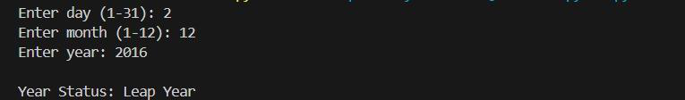

**Matrix Table (Condition/Decision Table):-**

|  |  |  |  |  |  |  |  |  |
| --- | --- | --- | --- | --- | --- | --- | --- | --- |
| **Test**  **Case** | **Year** | **is_leap_year** | **Month** | **Valid**  **Month?** | **Day** | **Max**  **Days in Month** | **Day**  **Valid?** | **Output** |
| TC1 | 2024 | Yes | 2 | Yes | 29 | 29 | Yes | Valid Date |
| TC2 | 2023 | No | 2 | Yes | 29 | 28 | No | Invalid  Day for  the given month |
| TC3 | 2024 | Yes | 4 | Yes | 30 | 30 | Yes | Valid Date |
| TC4 | 2024 | Yes | 4 | Yes | 31 | 30 | No | Invalid  Day for |

**Enrollment No: 2203051050314 Student Name: KRITIKA JAIN Page |**



**Faculty of Engineering & Technology Subject Name: STQA**   
**Subject Code: 303105377**   
**B.Tech. CSE Year: 4rd / Semester: 7th**

|  |  |  |  |  |  |  |  |  |
| --- | --- | --- | --- | --- | --- | --- | --- | --- |
|  |  |  |  |  |  |  |  | the given month |
| TC5 | 2024 | Yes | 13 | No | 10 | - | - | Invalid Month |
| TC6 | 2024 | Yes | 0 | No | 10 | - | - | Invalid Month |
| TC7 | 2024 | Yes | 1 | Yes | 31 | 31 | Yes | Valid Date |
| TC8 | 2024 | Yes | 1 | Yes | 32 | 31 | No | Invalid  Day for  the given month |
| TC9 | 2000 | Yes | 2 | Yes | 29 | 29 | Yes | Valid Date |
| TC10 | 1900 | No | 2 | Yes | 29 | 28 | No | Invalid  Day for  the given month |

**Explanation of Columns:-**

**Column Meaning**

**Year** Input year

**is_leap_year** Whether the year is leap (based on logic)

**Month** Input month

**Valid Month?** Whether the month is in range 1-12

**Day** Input day

**Max Days in Month** Based on month and leap year (from month_days)

**Day Valid?** Whether day ≤ max days for that month

**Output** Result returned by is_valid_date()

**Enrollment No: 2203051050314 Student Name: KRITIKA JAIN Page |**



**Control Flow Graph:-**

**Faculty of Engineering & Technology Subject Name: STQA**   
**Subject Code: 303105377**   
**B.Tech. CSE Year: 4rd / Semester: 7th**

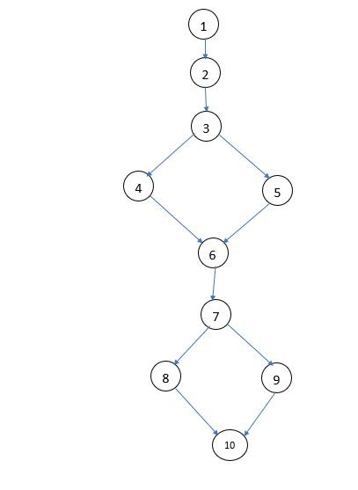

**Conclusion:-**

• Cyclomatic complexity is a useful metric to understand the testing needs of a

program.

• For the date validation problem, the complexity is 13, meaning at least 13 test

cases are needed for complete path coverage.

• Independent path testing ensures every possible logic condition is tested,

increasing code reliability.

**Enrollment No: 2203051050314 Student Name: KRITIKA JAIN Page |**



**Faculty of Engineering & Technology Subject Name: STQA**   
**Subject Code: 303105377**   
**B.Tech. CSE Year: 4rd / Semester: 7th**

**Experiment No: 4**

**Aim: - Design test cases using decision table design independent paths by taking DD path using date problem.**

**Solution:-**   
**Theory**   
Software testing ensures that the developed application behaves as expected under different conditions. One of the effective techniques for designing test cases is Decision Table Testing, especially when multiple input conditions affect the output.

In addition, to ensure path coverage, we analyze the program's Decision-to-Decision (DD) paths to generate independent paths and achieve maximum test coverage.

In this problem, we consider a program that validates a given date based on day, month, and year inputs.

**Step 1 — Understand the Problem**   
A date is **valid** if:   
 1.**Month**∈ {1..12}   
 2.**Day** depends on the month:   
 o31 days → Jan, Mar, May, Jul, Aug, Oct, Dec o30 days → Apr, Jun, Sep, Nov   
 oFeb → 28 days normally, **29 days in leap years**.

3.**Leap year rule**:   
 4.If (year % 400 == 0) OR (year % 4 == 0 AND year % 100 != 0) → Leap Year  **Step 2 — Decision Table Design**

|  |  |  |  |  |  |  |
| --- | --- | --- | --- | --- | --- | --- |
| **Condition** | **Rule 1** | **Rule 2** | **Rule 3** | **Rule 4** | **Rule 5** | **Rule 6** |
| Month between 1–12? | N | Y | Y | Y | Y | Y |
| Month has 31 days? | — | Y | N | N | N | N |
| Month has 30 days? | — | N | Y | N | N | N |
| February? | — | N | N | Y | Y | Y |
| Leap year? | — | — | — | Y | N | N |
| **Day ≤ max days?** | — | Y | Y | Y | Y | N |

**Enrollment No: 2203051050314 Student Name: KRITIKA JAIN Page |**



**Faculty of Engineering & Technology Subject Name: STQA**   
**Subject Code: 303105377**   
**B.Tech. CSE Year: 4rd / Semester: 7th**

|  |  |  |  |  |  |  |
| --- | --- | --- | --- | --- | --- | --- |
| **Action** | Invalid | Valid | Valid | Valid | Valid | Invalid |

**Explanation of Rules**   
 • **Rule 1** → Invalid month → **Invalid Date**  
 • **Rule 2** → Month with 31 days and valid day → **Valid** • **Rule 3** → Month with 30 days and valid day → **Valid** •  
 **Rule 4** → February in leap year → **Valid if day ≤ 29** • **Rule 5** → February in non-leap year → **Valid if day ≤ 28** • **Rule 6** → February day > 29 or any invalid day → **Invalid**

**Step 3 — Test Cases from Decision Table**

|  |  |  |  |  |
| --- | --- | --- | --- | --- |
| **TC No.** | **Day** | **Month** | **Year** | **Expected Result** |
| TC1 | 15 | 13 | 2023 | Invalid (Month > 12) |
| TC2 | 31 | 1 | 2023 | Valid (Jan, 31 days) |
| TC3 | 31 | 4 | 2023 | Invalid (Apr has 30) |
| TC4 | 29 | 2 | 2024 | Valid (Leap year) |
| TC5 | 29 | 2 | 2023 | Invalid (Not leap) |
| TC6 | 30 | 2 | 2024 | Invalid (>29 Feb) |
| TC7 | 28 | 2 | 2023 | Valid |
| TC8 | 0 | 5 | 2023 | Invalid (Day=0) |
| TC9 | 31 | 12 | 2020 | Valid (Dec, 31 days) |

**Step 4 — Design DD Path (Decision-to-Decision Path) Decision Points (Nodes)**   
 • **D1:** Check valid month   
 • **D2:** Check 31-day months   
 • **D3:** Check 30-day months   
 • **D4:** Check February   
 • **D5:** Check Leap Year   
 • **D6:** Check valid day ranges

**Enrollment No: 2203051050314 Student Name: KRITIKA JAIN Page |**



**Independent Paths**

**Faculty of Engineering & Technology Subject Name: STQA**   
**Subject Code: 303105377**   
**B.Tech. CSE Year: 4rd / Semester: 7th**

1.**P1:** Invalid month → D1 → Invalid   
 2.**P2:** Valid 31-day → D1 → D2 → Valid   
 3.**P3:** Invalid 31-day → D1 → D2 → Invalid   
 4.**P4:** Valid 30-day → D1 → D3 → Valid   
 5.**P5:** Invalid 30-day → D1 → D3 → Invalid   
 6.**P6:** Leap year Feb valid → D1 → D4 → D5 → Valid 7.**P7:** Leap year Feb invalid → D1 → D4 → D5 → Invalid 8.**P8:** Non-leap Feb valid → D1 → D4 → D5 → Valid 9.**P9:** Non-leap Feb invalid → D1 → D4 → D5 → Invalid Thus, we have **9 independent DD paths**.

**Step 5 — Final Output**   
 • Decision Table   
 • Test Cases   
 DD Paths •

**Enrollment No: 2203051050314 Student Name: KRITIKA JAIN Page |**



**Faculty of Engineering & Technology Subject Name: STQA**   
**Subject Code: 303105377**   
**B.Tech. CSE Year: 4rd / Semester: 7th**

**Experiment No: 5**

**Aim: - Understand the Automation Testing approach(theory concept).**

**Solution:-**   
**Theory**   
**Automation Testing** is a software testing approach where test cases are executed automatically using specialized testing tools instead of performing them manually.

It is used to improve the efficiency, speed, reliability, and accuracy of the testing process.

In Software Testing & Quality Assurance (QA), automation testing ensures that: • Repetitive tasks are tested quickly.

• Human errors are minimized.

• Software quality improves.

**Why Automation Testing?**

Manual testing is time-consuming and error-prone. Automation testing solves these issues by: • Reducing manual effort.

• Increasing test coverage.

• Executing regression tests quickly.

• Ensuring faster delivery of quality software.

**Automation Testing Approach:-**   
The automation testing approach defines how, when, and where automation should be used in the software testing lifecycle.

It includes the following steps:   
Step 1 — Identify Areas for Automation   
 • Not all tests should be automated.

Best suited for: •  
 oRepetitive test cases   
 oRegression testing   
 oPerformance testing   
 oLarge data-driven tests   
Step 2 — Select the Right Automation Tool

**Enrollment No: 2203051050314 Student Name: KRITIKA JAIN Page |**



• Choose a tool based on:

**Faculty of Engineering & Technology Subject Name: STQA**   
**Subject Code: 303105377**   
**B.Tech. CSE Year: 4rd / Semester: 7th**

oTechnology stack of the application.

oProject requirements.

oBudget constraints.

• Examples:   
 oSelenium, Appium, Cypress → Web & mobile testing oJUnit, TestNG → Unit testing   
 oJMeter → Performance testing   
Step 3 — Define the Automation Scope   
 • Decide what to automate and what to test manually.

• Focus on high-priority, stable, and repeatable scenarios.

Step 4 — Create the Test Automation Framework   
A framework provides guidelines and best practices for automation: Types of frameworks: •  
 oData-Driven Framework → Uses external test data.

oKeyword-Driven Framework → Uses keywords for test execution. oHybrid Framework → Combines data-driven + keyword-driven.

oBehavior-Driven (BDD) → Uses natural language (e.g., Cucumber).

Step 5 — Develop and Execute Test Scripts   
 • Write automation test scripts using tools like Selenium, JUnit, or TestNG. • Integrate scripts with the framework.

• Execute tests automatically.

Step 6 — Analyze Results and Generate Reports   
 • Compare actual results vs expected results.

Generate reports showing pass/fail status. •  
• Log defects for failed cases.

Step 7 — Maintain Automation Scripts   
 • Update scripts when:   
 oApplication features change.

oUI layouts are modified.

**Enrollment No: 2203051050314 Student Name: KRITIKA JAIN Page |**



**Faculty of Engineering & Technology Subject Name: STQA**   
**Subject Code: 303105377**   
**B.Tech. CSE Year: 4rd / Semester: 7th**

• Ensures test scripts remain reusable and reliable. **Advantages of Automation Testing:-**

Advantage Description

Faster Execution Automated scripts run faster than manual testing.

Reusability Same scripts can be used across multiple test cycles.

Better Accuracy Eliminates human errors during testing.

Improved Test Coverage Can run thousands of test cases quickly.

Continuous Testing Supports CI/CD pipelines for DevOps.

**Disadvantages / Limitations:-**

|  |  |
| --- | --- |
| Limitation | Description |
| High Initial Cost | Tools and framework setup require investment. |
| Not Suitable for All Tests | Exploratory, usability, and ad-hoc testing still need humans. |
| Maintenance Overhead | Scripts must be updated when the application changes. |
| Learning Curve | Requires technical skills for scripting and tool usage. |

**When to Use Automation Testing ?**

Automation is most effective when:   
 • Tests are repetitive.

• Application is stable.

• Regression testing is needed.

• Performance or load testing is required.

• CI/CD pipelines are implemented.

**Example:-**   
Scenario: Credit Card Payment System   
 • Manual Testing: Enter card details → click Pay → verify success message.

• Automation Testing:   
 oUse Selenium to simulate entering details automatically.

oCheck if success or error messages match expected results.

**Enrollment No: 2203051050314 Student Name: KRITIKA JAIN Page |**



**Faculty of Engineering & Technology Subject Name: STQA**   
**Subject Code: 303105377**   
**B.Tech. CSE Year: 4rd / Semester: 7th**

oRun 100+ test cases in seconds instead of hours.

**Conclusion:-**

The automation testing approach is essential in modern software testing and QA because:

• It reduces manual effort.

• Increases speed and efficiency.

• Improves software reliability.

• Supports continuous integration and delivery.

By using the right tools, frameworks, and strategies, teams can ensure high-quality software

in less time and with fewer resources.

**Enrollment No: 2203051050314 Student Name: KRITIKA JAIN Page |**